Bank Account Simulation

Members:
Tanishk Srivastava-1262253894
Anvi Todkar-1262252159
Tanvi Patil-1262250431
Austy Francis-1262250369
Abhinav Nair-1262253404

Project Guide

Submission Date -18/02/2026

Abstract
This project focuses on developing a simple Bank Account Simulation system using the C programming language. The program allows the user to create a bank account by entering basic details such as account number, account holder name, initial balance, and a security PIN. It provides a menu-driven interface to perform essential banking operations like displaying account details, depositing money, withdrawing money, and checking transaction history. PIN verification is implemented for secure access to sensitive operations such as withdrawal and transaction history. The program also maintains records of total deposited amount, total withdrawn amount, and the last transaction performed. This simulation helps in understanding the use of structures, conditional statements, loops, and switch-case in C programming while demonstrating the basic working of a banking system.

Table of Contents
1 | Introduction
2 | System Design/Methodology
3 | Implementation
4 | Results and Discussion
5 | Conculsion
6 | Future Scope
7 | References

Introduction
1. Problem Statement
The problem addressed in this project is to design and implement a Bank Account Simulation System using the C programming language. The system should allow a user to create a bank account and perform basic banking operations such as depositing money, withdrawing money, viewing account details, and checking transaction history. The project also ensures security by using a PIN verification system for sensitive operations.

2. Background / Context
Banking systems are widely used in real life for managing customer accounts and performing daily financial transactions. In real banks, customers can deposit money, withdraw money, check balances, and view transaction details using secure authentication methods like PIN or passwords.
This project is a simplified simulation of such a banking system. It is developed using C programming concepts such as structures, loops, switch-case statements, and conditional statements. This helps in understanding how basic banking functionalities can be implemented in software applications.

3. Objectives
The main objectives of this project are:
- To develop a menu-driven bank account program in C.
- To allow the user to create a bank account by entering account details.
- To perform basic banking operations such as:
  - Deposit money
  - Withdraw money
  - Display account details
  - Check transaction history
- To implement PIN-based security for withdrawal and transaction history.
- To maintain records of:
  - Total deposited amount
  - Total withdrawn amount
  - Last transaction details
- To enhance understanding of fundamental C programming concepts like structures, switch-case, and loops.

System Design / Methodology
Overview of the Approach
The project is designed using a menu-driven approach in C programming.
First, the user creates a bank account by entering account details such as account number, name, PIN, and initial balance. After account creation, the program repeatedly displays a menu using a loop. The user selects options to perform banking operations like deposit, withdrawal, viewing account details, and transaction history.
Security is ensured by using PIN verification for sensitive operations like withdrawal and transaction history. The program updates the balance after every successful transaction and also stores transaction details such as total deposit, total withdrawal, and last transaction.

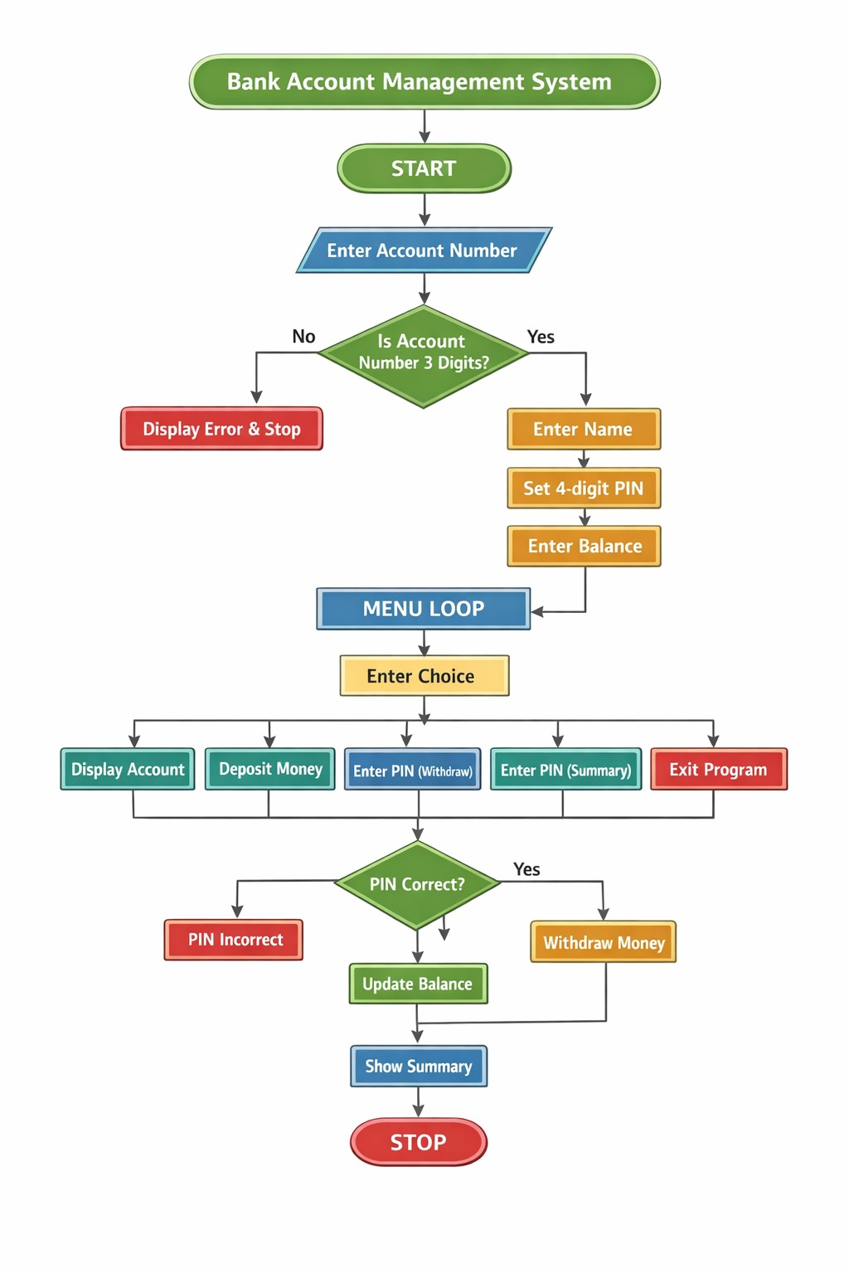
Program Modules
- Account Creation Module
  - Takes input of account number, name, PIN, and initial balance.
  - Validates account number.
- Menu Module
  - Displays available banking options.
  - Takes user choice.
- Deposit Module
  - Accepts deposit amount.
  - Adds amount to balance.
- Withdraw Module
  - Requires PIN verification.
  - Withdraws amount only if sufficient balance is available.
- Transaction History Module
  - Requires PIN verification.
  - Displays total deposited, total withdrawn, and last transaction.
- Exit Module
  - Ends the program safely.

Algorithms or Techniques Used
Techniques Used
- Structure (struct) to store account information.
- Loop (while(1)) to repeatedly display menu until exit.
- Switch-case for selecting menu operations.
- Conditional Statements (if-else) for validation.
- PIN Authentication for security.
Algorithm Used
- Input account details and validate account number.
- Display menu repeatedly.
- Perform deposit or withdrawal based on user choice.
- Validate PIN for withdrawal and transaction history.
- Update balance and store transaction details.
- Exit when user selects option 5.

Implementation
Development environment - https://www.programiz.com/online-compiler/8NT6SoqQrBPtf
Code Screenshots
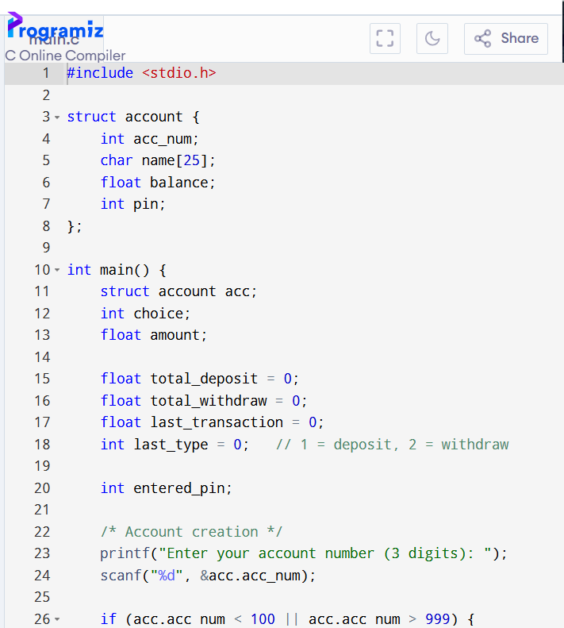

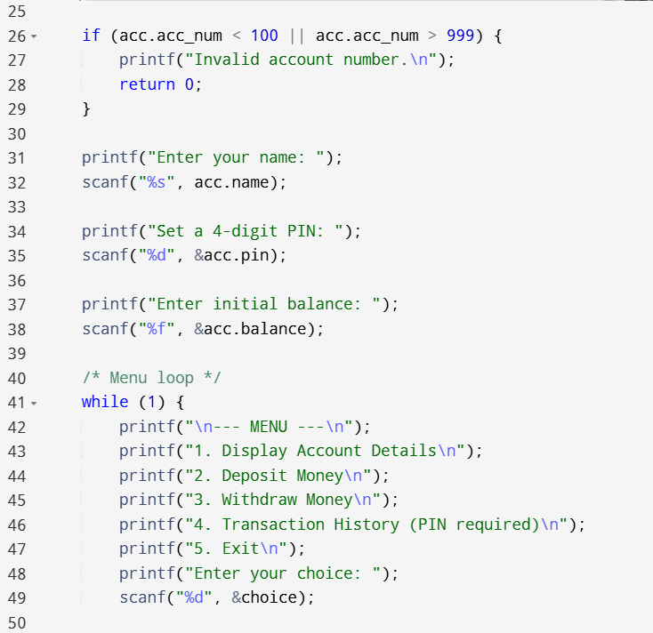
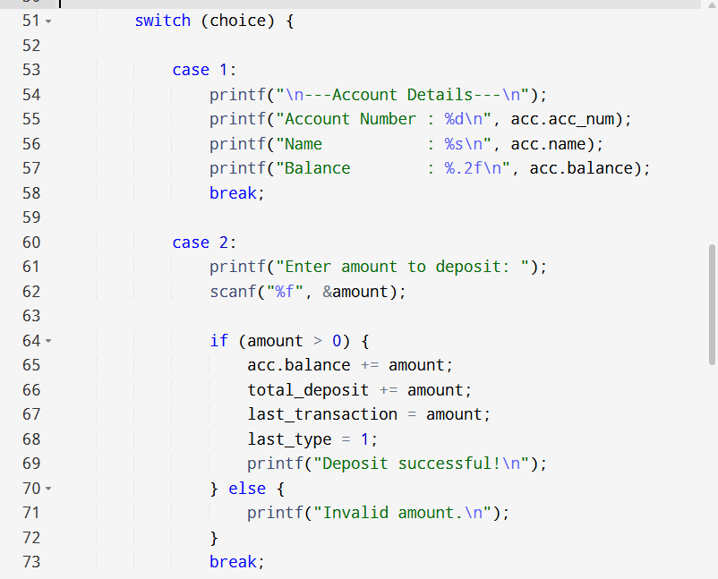
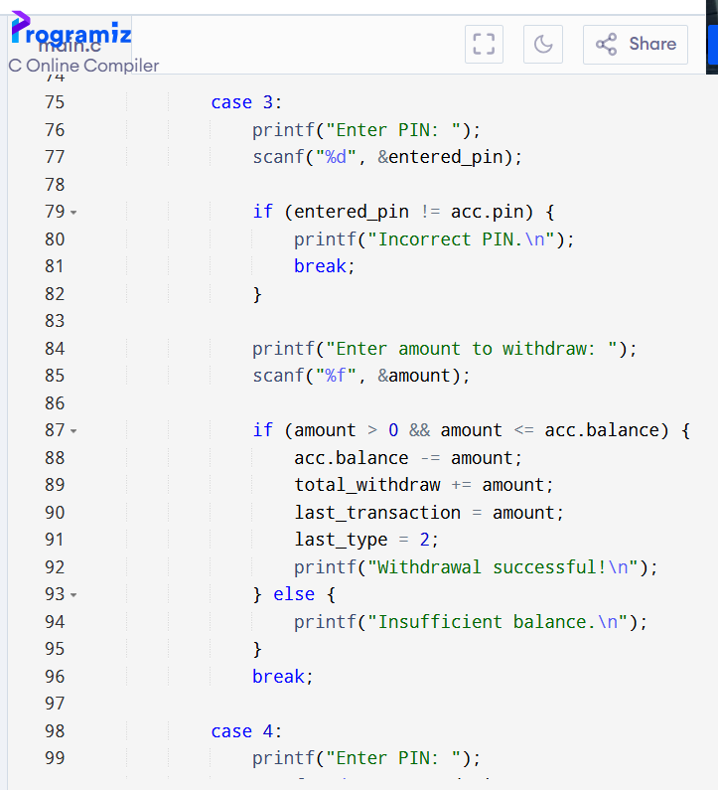
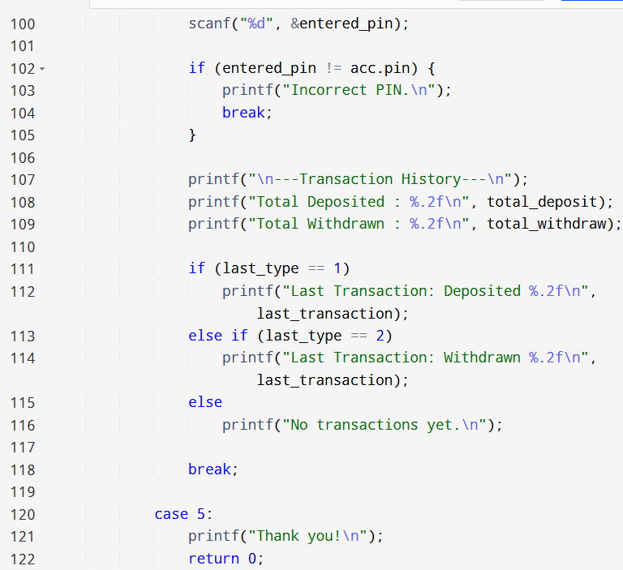
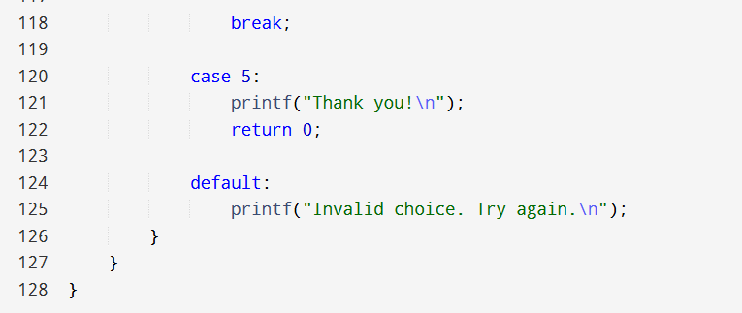

Results
The output of the Bank Account Simulation project is obtained through a menu-driven interface. After account creation, the program successfully allows the user to perform banking operations such as displaying account details, depositing money, withdrawing money (with PIN verification), viewing transaction history, and exiting the program. The system updates the account balance correctly after every deposit and withdrawal transaction. It also displays total deposited amount, total withdrawn amount, and last transaction details under the transaction history option.
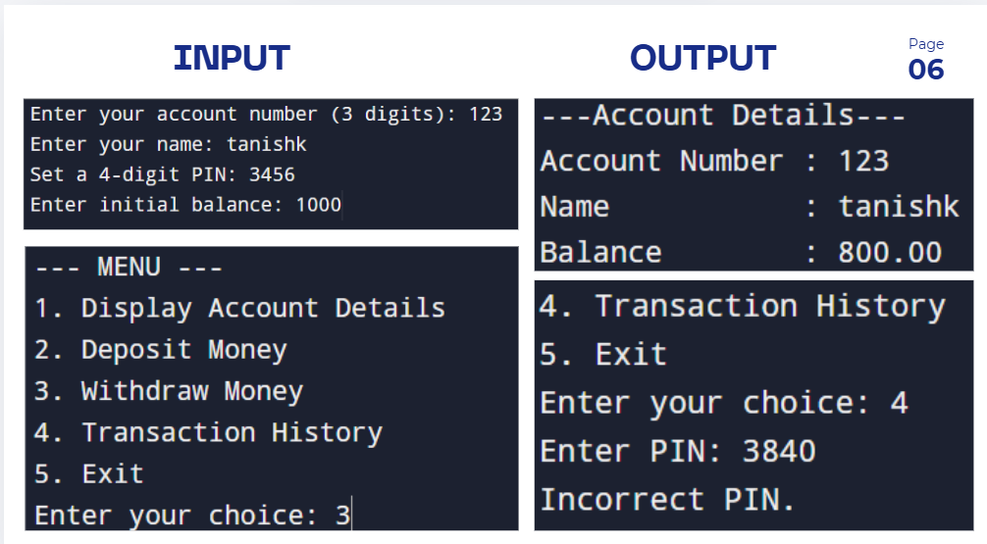

Analysis
The results obtained from the project align well with the objectives defined earlier:
- The objective of creating a menu-driven bank system is achieved successfully using loop and switch-case.
- The program correctly performs deposit and withdrawal operations while updating the balance.
- The security objective is fulfilled by implementing PIN verification for withdrawal and transaction history.
- The program also meets the objective of maintaining transaction information such as:
  - Total deposited amount
  - Total withdrawn amount
  - Last transaction performed
- Overall, the project demonstrates the proper use of structures, conditional statements, and loops to simulate basic banking operations effectively.

Conclusion
The Bank Account Simulation project was successfully developed using the C programming language. The system provides a simple and user-friendly menu-driven interface to perform basic banking operations such as account creation, deposit, withdrawal, balance enquiry, and transaction history. Security is ensured through PIN verification for sensitive operations like withdrawal and transaction history. The project helped in understanding the practical use of C concepts such as structures, loops, switch-case, and conditional statements. Overall, the project meets the objectives and demonstrates a basic working model of a banking system.

Future Scope
The project can be further enhanced by adding more advanced banking features such as:
- Supporting multiple bank accounts instead of a single account.
- Using file handling to store account details permanently.
- Adding a login system with account number and PIN.
- Maintaining a complete transaction history (mini statement).
- Adding features like fund transfer, interest calculation, and change PIN option.
- Implementing PIN attempt limit and account locking for better security.
- Improving user interface and adding validations for all inputs.

